

**CS262L Data Structures and**

**Algorithms (Pr)**

**Lab Manual (Week 1)**



**Instructor:**

|  |  |  |
| --- | --- | --- |
| ● | Mr. Nazeef Ul Haq | Registration No.__________________  Name: _________________________ |

**Guide Lines/Instructions:**

* Use of Spyder IDE/Anaconda in this lab.
* Create meaningful variable names. Add comments for readability. Indent each line of your code.
* Plagiarism/Cheating is highly discouraged by penalizing to both who tried and one who shared his/her code.

**Today’s Task:**

* Python Environment Setup using Spyder IDE
* Get comfortable with the Python Syntax Specifically Arrays
* Learn to write recursive tasks

**Installation Guideline:**

* Go to the website [Home --- Spyder IDE](https://www.spyder-ide.org/) and click the download button at the bottom or download from the direct link [Spyder Install](https://github.com/spyder-ide/spyder/releases/latest/download/Spyder_64bit_full.exe) (221 MB).
* Run the setup file according to Figure 1. Complete the installation with the emerging instructions.

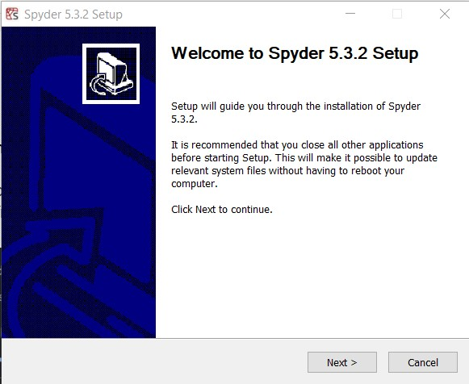

*Figure 1 Spyder Installation Interface*  ● Launch the Spyder from the installation directory.

* You will see the interface according to Figure 2.
* Write your first program in python

print ("Hello to Data Structure and Algorithms Course")

* Note that python does not require the program template as required in C++ and C#.

1

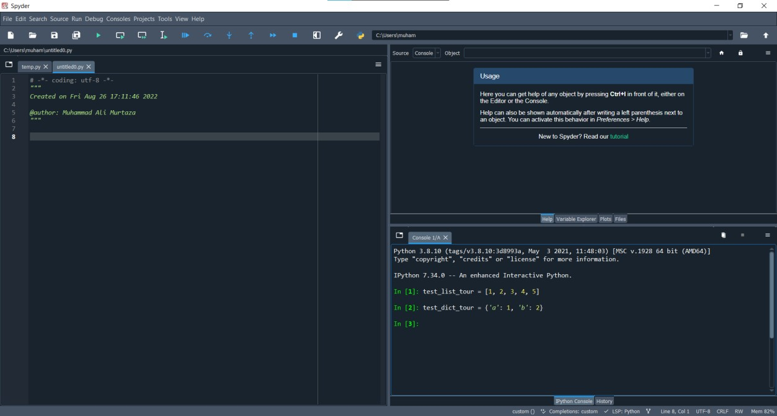

*Figure 2 Spyder IDE Home Screen*

**Part1: Getting Comfortable with Python Activity 1:**

Run the above code using command prompt. Write below the process of running program from cmd (commands).

|  |
| --- |
|  |

**Activity 2:**

Describe the process of code compilation and execution in python. How the byte code will be generated? How the process is different from C#. Write in your own words.

|  |
| --- |
| **Code Compilation and Execution in Python:**  You start with your Python source code (those .py files). This is the human-readable version of your program. Python uses a Lexer and a Parser to understand your code. The Lexer reads your code and turns it into a bunch of tokens (like words in a sentence). The Parser then takes these tokens and builds a tree-like structure that represents the syntax of your program. This tree-like structure is called an Abstract Syntax Tree (AST). It's like a blueprint of your code's logic.  Now, here's where the magic starts. Python doesn't directly execute your source code. It compiles the AST into something called "bytecode". This is a lower-level, platform-independent representation of your code. This bytecode is saved in files with a .pyc extension. These files are what Python actually executes. They're like an intermediate step between your source code and the machine code that your computer's processor understands. When you run your Python script, the Python Virtual Machine (PVM) kicks in. It's like a simulator for a computer that understands and executes Python bytecode. The PVM reads the .pyc files and follows the instructions they contain.      **Code Compilation and Execution in C#**  Just like Python, you start with your source code (.cs files). C# has a robust compiler that does a bit more work upfront compared to Python. It also uses a Lexer and Parser, but it goes a step further by performing something called "Semantic Analysis". This checks things like variable types and ensures everything makes sense.  Instead of directly generating machine code, C# compiles to something called Intermediate Language (IL). This is similar to Python bytecode. It's platform-independent and needs a specific runtime to execute. The CLR is like the PVM for C#. It's part of the .NET framework and handles the execution of the IL code. It takes care of things like memory management, garbage collection, and security. Here's where C# differs significantly from Python.  When you run a C# program, the CLR doesn't execute the IL directly. It uses a Just-In-Time compiler to convert the IL into native machine code just before it's executed. This can lead to faster execution times.  **Conclusion**  So, in a nutshell, while Python compiles to bytecode that's executed by a virtual machine, C# compiles to IL, which is then further compiled to native machine code by the CLR at runtime. This extra compilation step in C# is one reason it can sometimes be faster than Python for performance-intensive tasks. |

Here are some examples that will provide you the roadmap of Conversion from C# to Python.

**Example 1.1: Write a Program to display value**

|  |  |
| --- | --- |
| **C#** | **Python** |
| using System;  public class ConsoleApp1  {  public static void Main()  {  // declare variable with int datatype int a = 5;  // prints the string  System.Console.WriteLine("The value of a is: " + a);  }  } | # No compulsory library is required for simple programs  a = 5    # no terminator restriction    print("The value of a is: ", a) |

**Example 1.2: Input value from User**

|  |
| --- |
| a = input (“Enter the value:”) #a is string    #conversion of string to int data type b = int(a)    print (“Entered value is:” + str(b))    #We need to convert int type variable to string. Because in python concatenation of int and string type variables is not possible without conversion. |

**Example 1.3: Array Declaration of 1D and 2D arrays**

|  |
| --- |
| #1D array declaration array = []  #Also initialize at the time of declaration array = [1,2,6,10,4]    #2D array  arr = [[1,3,2], [1,5,6]] |

**Activity 3:**

We do not specify the data type of variable in python. How python will infer the data type. How will you verify the data type of variable in python. Give convincing justification.

|  |
| --- |
| In Python, variables are dynamically typed, which means you don't need to explicitly specify their data type. Instead, Python infers the data type based on the value assigned to the variable.  For example, if you write **x=5** Python recognizes that x is an integer because you assigned it the value 5. If you later do something like x = "Hello", Python will now recognize x as a string. To verify the data type of a variable in Python, you can use the type() function. For example: x = 5 print(type(x)) Here's why this dynamic typing and type inference is advantageous: **1) Flexibility** It allows for more flexible coding. You can assign different types of values to a variable without having to worry about explicit type declarations.  **2) Code Readability** It can make your code more readable and concise. You don't need to clutter your code with type declarations. **3) Ease of Prototyping** It makes rapid prototyping easier. You can quickly write and test code without getting bogged down by type specifications. **4) Reduced Development Time** It can lead to faster development because you spend less time on type-related boilerplate code. **5) Easier Maintenance** Dynamically typed languages can be more forgiving when it comes to changes. You can modify a variable's type without needing to update its declaration. |

**Example 1.4: Array of Zeros**

array = 0 * 10 #array of length 10 having all zeros

#2D array having all zeros array1 = [[0 for x in range(4)] for y in range(3)]

#we can perform the same task more easily using numpy library

TODO—add numpy code for zeros

**Example 1.5: 1D array of Random ints**

|  |
| --- |
| import random array = [] min = 0 max = 20 n = 5 for i in range (0, n):  num = random. randint (min, max)  array. append (num)    #Process the same using numpy  --to-do add numpy code |

**Example 1.6: Traversal of an array**

|  |  |
| --- | --- |
| #Traverse in forward direction using for loop  str = [“U”, “E”, “T”] for x in range(len(str)): print(str[x])    array = [32, 1, 9, 31, 12, 22]    # Reverse by using a slice # slice (start, end, step)  print(array[::-1]) | #Traverse in backward direction using reverse method array.reverse() print(array)    #Traverse through an array using for loop for i in range(len(array)-1, -1, -1): print(array[i]) |

**Example 1.7: Slicing of Arrays—Extracting subarrays**

Slicing in Python is a feature that enables accessing parts of sequences like strings, tuples, and lists. Here are some examples on arrays that would explain slicing.

|  |  |  |
| --- | --- | --- |
| **Starting subarray** | **Middle subarray** | **Ending subarray** |
| >>> arr = [1,2,3,4,5]  >>> arr [:2]  [1, 2] | >>> arr = [1,2,3,4,5]  >>> arr [1:3]  [2, 3] | >>> arr = [1,2,3,4,5]  >>> arr [2:]  [3, 4, 5] |
| **Important**  In python, subarrays can also be extracted through negative indices.  >>> arr = [1,2,3,4,5]  >>> arr [-2:]  [4, 5]    Here -1 means the first element from last. -2 means second element from last. | | |

**Example 1.8: Read data from File**

Let say we have single file for this code testing named **test.txt** and we have single line written in it as: given_file = open (file = 'test.txt', mode = 'r')



1

2

3

4

5



test.txt

lines = given_file. read ()

numbers = []

arr = lines.split()

for s in

arr:

num = int(s)

numbers.append(num)

print(numbers)

**Note:**

Example modes for opening file in python are:

w → Write mode r → Read Mode

a → Append Mode

x → Open for exclusive creation, failing if the file already exists

**Example 1.9: Write data to File**

|  |  |
| --- | --- |
| #Write array elements one per line to file    arr = ['Hello world', 'UET'] f = open (file="test.txt", mode="w") for i in arr:  f.write (i + "\n") | **Output:**    Hello World  UET |

**Example 1.10: Play with functions**

|  |  |
| --- | --- |
| **Pass an array to function** | **Return array from function** |
| def display(arr): for i in arr: print(i)    array = [1, 2, 3, 4, 5, 6, 7, 8, 9] display(array) | def get_name (): names = ['Ali', 'Ahmad', 'Hassan'] return names    names= get_name () |

**Activity 4:**

What are mutable and immutable data types in python. Give at least three examples for each.

|  |
| --- |
| **Immutable** types cannot be changed after they are created. When you perform operations on them, a new object is created. For example,   1. Int 2) Float 3) String   **Mutable** types, on the other hand, can be modified after they are created. When you perform operations on them, the object itself is changed. For example,   1. List 2) Directory 3) Set |

# Part 2: Think Recursively

**Example 2.1: Calculate sum of integers**

|  |  |
| --- | --- |
| **Iterative** | **Recursive** |
| sum = 0 for i in range (11): sum += i    print(sum) | def sum(n): if n == 0: return n else: return n + sum(n-1) print (sum (10)) |

**Example 2.2: Print array of elements**

|  |  |
| --- | --- |
| **Iterative** | **Recursive** |
| arr = [1,2,3,4,5,6,7,8,9,10]  for i in arr: print(i) | def printArray (arr, start, end): if start == end:  print(arr[start]) else: print(arr[start])  printArray (arr, start+1, end)  arr = [1,2,3,4,5,6,7,8,9,10] printArray (arr, 0, len(arr)-1) |

**Example 2.3: Calculating power function through recursion.**

|  |  |
| --- | --- |
| **Iterative** | **Recursive** |
| num = 2 power = 5 result = 1 for i in range(power): result = result * num    print(result) | def power (n, k): if k == 1: return n else: return n * power (n, k-1) |

**Example 2.4: Factorial of Number using recursion**

|  |
| --- |
| **def** recur_factorial(num):  if num < 0: return -1 elif num == 0 || num == 1:  return 1 else:  return n*recur_factorial(n-1) num = int(input("Enter a number: "))  print("The factorial of",num,"is",recur_factorial(num)) |

**Activity 5:**

What is recursion? Give some prose and cons of recursion.

|  |
| --- |
| Recursion is a programming concept where a function calls itself in order to solve a problem. In other words, it's a technique where a problem is divided into smaller subproblems of the same type, and the function continues to call itself on these smaller subproblems until a base case is reached, at which point the solutions are combined to solve the original problem. |
| **Pros**  1. Elegance and Readability  Recursive solutions can often be more elegant and easier to understand than iterative solutions. They allow you to express complex algorithms in a more natural, self-referential way.  2. Solving Complex Problems  Recursion is particularly useful for solving problems that can be broken down into smaller, similar subproblems. Examples include tree traversal, searching, and sorting algorithms.  3. Reduced Code Length  In many cases, recursive code can be shorter and more concise than equivalent iterative code, which can lead to fewer opportunities for bugs. |
| **Cons**  1. Performance Overhead  Recursive calls can be less efficient than iterative solutions because they involve function call overhead and can lead to a larger memory footprint due to the call stack. This can be a concern for very large or deeply nested recursive calls.  2. Stack Overflow  If not implemented carefully or if there is no proper termination condition (base case), recursion can lead to a stack overflow error, causing the program to crash. |

**Activity 6:**

How recursive function is evaluated in memory. Give some details

|  |
| --- |
| **Steps**   1. The initial call to the recursive function is made. 2. A new stack frame (also known as an activation record or call frame) is created for each function call. This frame holds the local variables, parameters, and return address specific to that call. 3. The parameters and local variables of the function are allocated memory within this stack frame. 4. The function checks if it has reached a base case. The base case defines a condition that, when met, stops the recursion. If the base case is met, the function returns a value. 5. If the base case is not met, the function makes a recursive call to itself. This means that a new stack frame is created for the recursive call, and the process repeats. 6. As each recursive call creates a new stack frame, the intermediate results are stored in these frames. These results are used to compute the final result when the base case is reached. 7. When the base case is finally met, the function starts "unwinding" the stack. This means that the function starts to return values, one by one, back up the chain of recursive calls. 8. As each stack frame's return value is used, that frame is deallocated from memory. This process continues until the initial function call returns. |

**Note:**

1. Whenever you are asked to read array, your are required to load array from the file, reading each element per line.
2. Do not take input from console for array.

**Problems**

|  |  |
| --- | --- |
| 1. Look for the index of the given element x in the given array:  X = [22,2,1,7,11,13,5,2,9]    SearchA(Arr, x) – return array of indices    Arr: Array  x: element to be searched | **Input**: Enter the number: 2  **Output**: Index: 1,7 |
| 2. Answer question 1 in the scenario where the input array is already sorted.  How much elements you need to check in sorted array.    SearchB(Arr, x)-- return array of indices    Arr: Array x: element to be searched | **Input**: Enter the number: 2  **Output**: Index: 1,7 |
| 3. Write a function that takes an array as input, starting and ending index and return the index of minimum element from start to ending index in the array.    Minimum(Arr, starting, ending)— return integer | For example, you are given the following inputs  Array: [3,4,7,8,0,1,23,-2,-5]  StartingIndex: 4  EndingIndex: 7    Output: (Return index of minimum element) 7 |
| **4.** Sort an array X using the above generated function.    **Hint:** Find the smallest element from the unsorted part of the array repeatedly and place it at the start of the array.    Sort4(Arr)—return array Arr: Array to be sorted | **Output**: X = [-5, -4, -3, 0, 1, 1, 4, 35,  100, 101] |
| 5. Extract the relevant portion and print it in the reverse direction from the string s = **"University of Engineering and Technology Lahore"**.  Without using any loop and reverse () method.      StringReverse(str, starting, ending)—returns string | **Output**: "ygolonhceT dn" |
| 6. Given a number, the task is to find the sum of its digits using an iterative and recursive method.    SumIterative(number) – returns integer    SumRecursive(number)-- returns integer | **Input**: 1524  **Output**: Sum of digits is: 12 |
| 7. Find the sum of the given matrix both column- and row-wise.    1 13 13  A = [5 11 6]  4 4 9      ColumnWiseSum(Mat) – returns 1d array  RowWiseSum(Mat) – returns 1d array | 27  **Output**: Row-wise: 22  17      Column-wise: 10 28 28 |
| 8. Without using any sorting methods, combine two sorted arrays keeping the resultant array sorted in ascending order.     1. = [0,3,4,10,11] 2. = [1,8,13,24]     SortedMerge(Arr1, Arr2) – returns sorted array | **Output:** [0,1,3,4,8,10,11,13,24] |
| 9. Write a recursive function that takes a string and returns if the string is palindrome or not.    PalindromRecursive(str)- returns a boolean | **Input:** "radar"  **Output:** Palindrome |
| 10. Sort the given array so that the elements are arranged in the following way while taking ascending order into consideration  Sort10(Arr)—returns array | **Input:** [10, -1, 9, 20, -3, -8, 22, 9, 7]  **Output:** [-8, 7, -3, 9, -1, 9, 10, 20, 22] |

**What to Submit:**

1. Only .py files are allowed.
2. For Lab1, you are required to write all functions in single file, funcs.py
3. For each problem, create a driver .py file

a. Lab1.py

1. Functions names input and output should be exactly same.
2. Zip all files, and submit on eduko